***A Mini Project Report on***

**CureMeNow: Healthcare Website**

**T.E. - I.T Engineering**

**Submitted By**

**Sakshi Gunjal 20104106**

**Ashmina Dangat 20104052**

**Neha Chaudhary 20104134**

**Under The Guidance Of**

**Prof. Mansi Choche**



**DEPARTMENT OF INFORMATION TECHNOLOGY**

A.P. SHAH INSTITUTE OF TECHNOLOGY

G.B. Road, Kasarvadavali, Thane (W), Mumbai-400615

UNIVERSITY OF MUMBAI

Academic year: 2022-23

**CERTIFICATE**

This to certify that the Mini Project report on CureMeNow Website has been submitted by Sakshi Gunjal 20104106, Ashmina Dangat 20104052 and Neha Chaudhary 20104134 who are Bonafide students of A. P. Shah Institute of Technology, Thane, Mumbai, as a partial fulfilment of the requirement for the degree in **Information Technology**, during the academic year **2022-23** in the satisfactory manner as per the curriculum laid down by University of Mumbai.

Prof Manasi Choche

Guide

Prof. Kiran Deshpande Dr. Uttam D. Kolekar

Head Department of Information Technology Principal

External Examiner(s)

1.

2.

Place: A.P. Shah Institute of Technology, Thane

Date:

**ACKNOWLEDGEMENT**

This project would not have come to fruition without the invaluable help of our guide Prof. Mansi Choche. Expressing gratitude towards our HoD, **Prof. Kiran Deshpande**, and the Department of Information Technology for providing us with the opportunity as well as the support required to pursue this project. We would also like to thank our teacher Ms. Roshna Sangle who gave us her valuable suggestions and ideas when we were in need of them. We would also like to thank our peers for their helpful suggestions.

**TABLE OF CONTENTS**

1.Introduction………………………………………………………………..5

* 1. Purpose………………………………………………………………..5
  2. Problem Statement……………………………………………………6
  3. Objectives…………………………………………………………….6
  4. Scope…………………………………………………………………6

2. Literature Review…………………………………………………………7

3. Proposed System…………………………………………………………..9

3.1Features and Functionality……………………………………………9

4.Requirements Analysis…………………………………………………….10

5.Project Design……………………………………………………………...11

* 1. Block diagram……………………………………………………11

b. Used case diagram………………………………………………11

6.Technical specification…………………………………………………….12

7.Project Scheduling…………………………………………………………13

8.Implementation…………………………………………………………….15

9.Conclusion and Future Scope……………………………………………...19

10.References…………………………………………………………………20

**Chapter 1**

**Introduction**

Hospitals, clinics, and community health agencies can be very different from other work environments. Healthcare systems are complex and there are many things you need to know about types of hospital systems, patient care, insurance, healthcare providers and legal issues.

CureMeNow is a user-friendly healthcare website most prominently used during emergencies and for general purposes. It is a convenient website which can be handled effortlessly by any age group. Its main aim is to provide a straightforward solution to the user considering their health problems. Usually, when there is a sudden minor health issue, we tend to visit websites that though to some extent give a solution but also scare the user with recommendations. Thus, to avoid this problem we have developed CureMeNow, which provides you with solutions starting from home remedies to locating a medical store nearby. This gives the user a choice according to their health conditions.

* **Problem Identified:**

The major problem arises when a user tries to search his/her problem on Google. There are n number of solutions and symptoms which generally tend to make people depressed. User usually get confused regarding which solution to approach.

* **Solution Proposed**:

CureMeNow has the perfect solution to the problem identified. It provides. legitimate information and solutions to all your minor health problems. It is quite convenient to use with consideration to all age groups. Also, our website assures users no stress concerned to the health problems.

**1.1Purpose**

The main purpose of our website is to give legitimate solutions to the user for their health problems. Offer the user the reliability of choosing the solution considering the recommendations provided by us. Since emergencies does not come considering age group, so we target all age groups from children to the old age. CureMeNow is designed for the purpose of lessening the stress factor in users. CureMeNow is a Flexible website to use. The website manages the data of daily orders.

**1.2 Problem Statement:**

No such website or application will provide users with specific solutions to their problems according to their choices. Even if we find one, then it isn't for the welfare of the users but also profits the admin.

**1.3 Objective**

* To help people reach medical stores in case of emergency.
* To reduce stress among the users regarding their health issues.
* To develop a user-friendly portal that can be accessible anytime and anywhere.
* To reduce the efforts of the users.
* To provide proper medications.
* To improve clinical decision-making.
* To improve clinical decision-making.
* To provide better medication management and reduce cost.

**1.4 Scope**

* Can be used in the health care sector.
* Can be used by all age groups except for children below 14.
* Patient-centric value services.
* Users can locate medical stores and hospitals nearby them.

**Chapter 2**

**Literature Review**

1. “Study on the information system of health care services management in hospital” Author(s): Damping Hu, Antai Sch. of Manage., Shanghai Jiaotong Univ., China Weiguo Xu; Huizhang Shen; Mengyu Li. Services Systems and Services Management, 2005. Proceedings of ICSSSM '05. 2005 International Conference This paper reviews the HIS (Hospital Information Systems) which are widely used in many hospitals in China mainly to provide easier and faster ways for daily medical tasks/activities with a GUI and overcome some of the limitations of HIS. So, the paper proposes HSMS (Hospital Services Management System) which aims at improving the quality of services, identifying cost reduction areas, analyses and evaluating/rating healthcare services. The ability to evaluate the services facilitates hospitals to achieve higher Customer satisfaction.
2. “Specification of a Reference Model for the Domain Layer of a Hospital Information System” by Gudrun Hübner-Blodera, Elske Ammenwertha, Birgit Brigl b, Alfred Winter b an Institute for Health Information Systems, UMIT – University for Health Sciences, Medical Informatics and Technology, Hall in Tyrol, Austria b Institute for Medical Informatics, Statistics and Epidemiology, University of Leipzig, Germany, ENMI, 2005. Many enterprise projects get scrapped due to the high costs involved in the initial planning requirement gathering and design phase. The costs in this phase become unmanageable due to a lot of unknown factors. Like lack of Subject area expertise, and lack of knowledge of different Hospital enterprise functions 1) Patient admission 2)Patient Treatment planning 3)Order Entry 4)execution of diagnostic and treatment procedures 5)administrative documentation 6)billing 7) Clinical documentation 8) discharge and 9) referral to specialised medical institutions, lack of knowledge /experience on the entities types involved ( example: patient, Clinical finding) , their roles and responsibilities and the relationships /associations between different enterprise function and /or entity types. This paper aims at creating a reference data model that will serve as a generic starting point for any new HIS development projects so costs involved in studying and analyzing the current state and coming up with gaps analysis and additional requirements can be significantly reduced. The model is Hierarchical in nature that is it is dived into 3 levels of sub models and units so a choice for full or partial implementation can be offered based on the requirements.

1. “Developing Effective Hospital Management Information Systems: A Technology Ecosystem Perspective”, by Dr Christopher Bain MBBS, Master Info. Tech Student No: 10054499 The author of this paper focuses more on the needs of hospital manager and the ecosystem in which he/she operates. The internal and external environment shaping factors ESFs that bear an impact or association on daily hospital activities and decision-making process that the hospital manager has to go through in each situation. Some of the challenges that this ecosystem needs to work on are high demand pressure, greater customer satisfaction level and low profit margins. This paper more so contributes to Planning, Design and development aspects of any Hospital management system by highlighting ESFs that should be considered. The external and internal factors the author mentions are: Internal influencer authors can obviously also be at play in terms of what services are provided by the hospital and how they are provided. These can include: the skills and experience of staff, internal business strategies such as competition and subsidization, soft factors such as morale and culture, Equipment availability.

**Chapter 3**

**Proposed System**

On this website, we provide various healthcare facilities to the users according to their problems. On this website, users can search for their minor health problems and then receive a solution for the same. It provides general recommendations with choices to select your solution.

**3.1 Features and Functionality**

* **Safe and Secure**: The user will receive a receipt after ordering any product from the website. Also, the information shared with the website regarding health is also secured.
* **Detailed Information**: The user can get detailed information about the problems he/she is facing on the website.
* **Tracking details:** Once the user purchases any product, you can track the details of the delivery.
* **Recommendations:** Users have availed the service of questionnaires where recommendations are provided.
* **Locate medical stores**: One of the major features of this website is that user can locate medical stores in case of emergency.
* **Feedback**: Users can review the experience of the website.

**Chapter 4**

**Requirement Analysis**

**Functional requirements**

* System must be able to verify and validate the information.
* The system must encrypt the password of the user to provide security.
* Username and password will be used for login after user registration is confirmed.

#### Software requirements

* Visual Studio Code
* Windows Operating System
* Xamp control panel

**Chapter 5**

**Project Design**

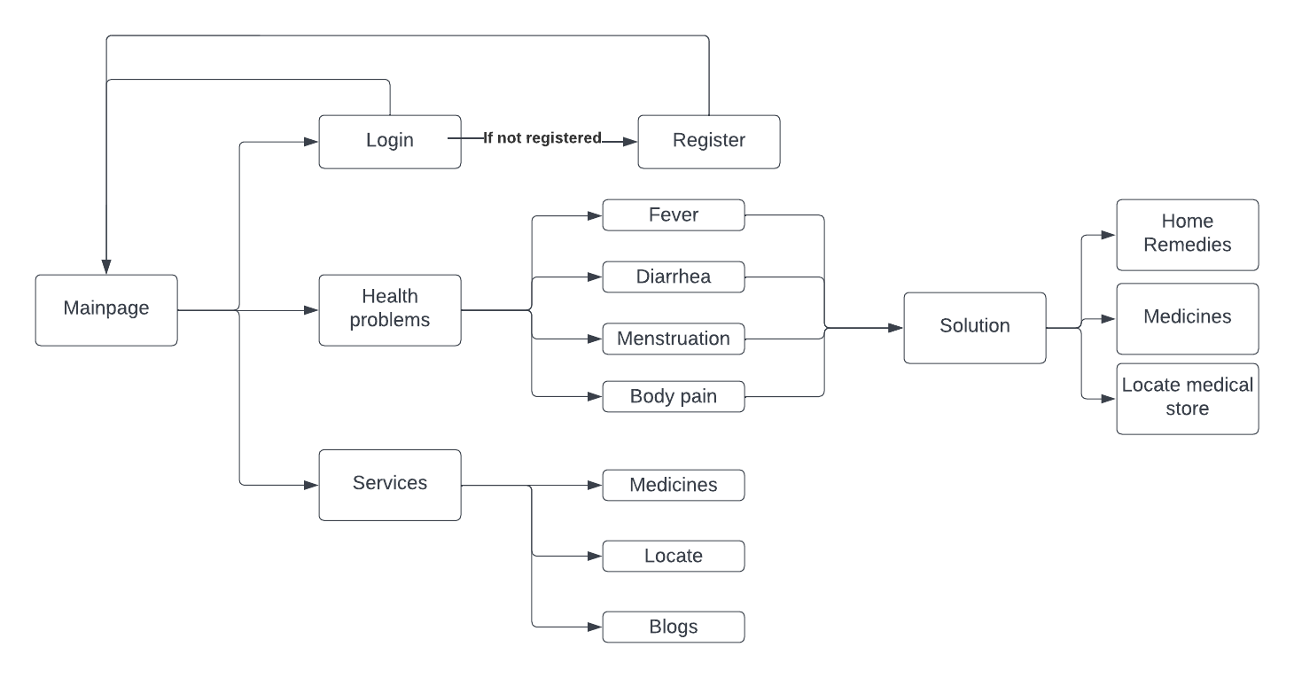

Fig. 5.1 Block diagram for CureMeNow Website

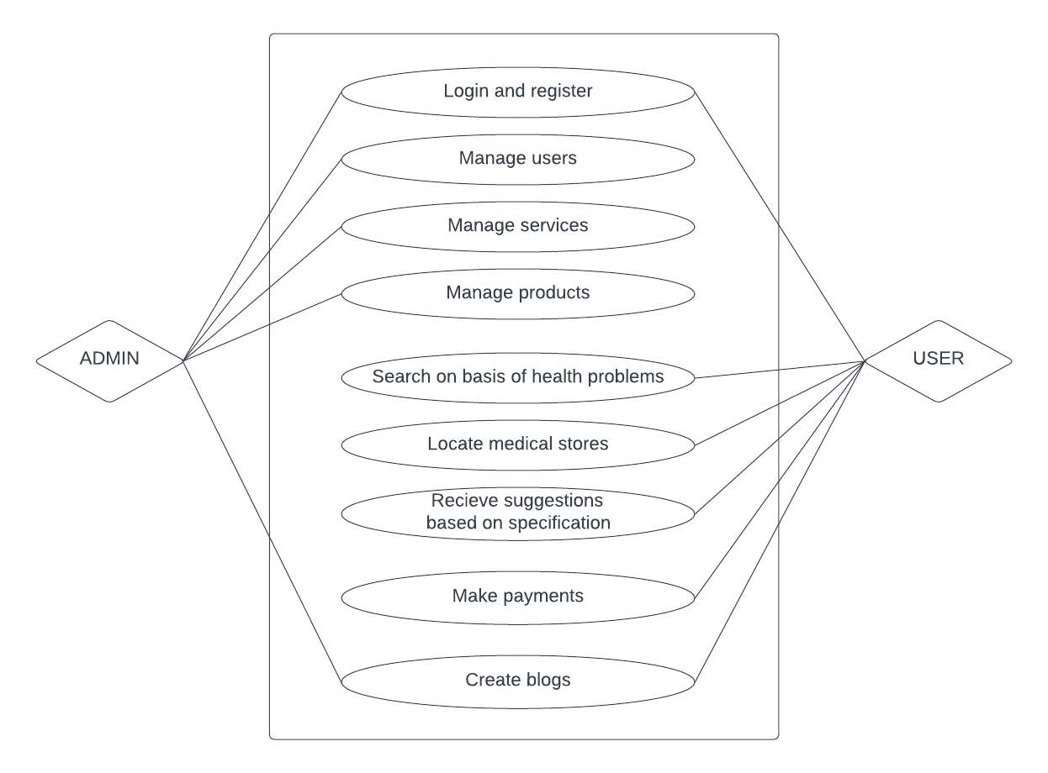

Fig. 5.2 Used case diagram of CureMeNow Website

**Chapter 6**

**Technical Specification**

**Development: VS Code**

VS Code also known as Visual Studio Code is a source code editor made by Microsoft for Windows, Linux, MacOS. It has various features such as Debugging, Syntax highlighting, extension, intelligent code completion.

**Frontend: Html, CSS, JavaScript**

As a web developer, the three main languages we use to build websites are HTML, CSS, and JavaScript. JavaScript is the programming language, we use HTML to structure the site, and we use CSS to design and layout the web page. These days, CSS has become more than just a design language, though. You can actually implement animations and smooth transitions with just CSS.

**OS: Windows**

Windows is a graphical operating system developed by Microsoft. It allows users to view and store files, run software, play games, and watch videos, and provides a way to connect to the internet. It was released for both home computing and professional works.

**Backend: PhP, MySQL**

With PHP, you can connect to and manipulate databases. MySQL is the most popular database system used with PHP. PHP combined with MySQL are cross-platform (you can develop in Windows and serve on a Unix platform). The data in a MySQL database are stored in tables. A table is a collection of related data, and it consists of columns and rows. Databases are useful for storing information categorically.

**Chapter 7**

**Project Scheduling**

**Project Scheduling Template**

|  |  |  |  |
| --- | --- | --- | --- |
| **Sr. No** | **Group Member** | **Time duration** | **Work to be done** |
| **1** | Sakshi Gunjal | 1st week of august | Implementing 1st module/ functionality (*Login and Register Page/ Validation to login and register page*) |
| 2nd week of august | Testing 1st module  (Shop Page */Add to cart functionality.*) |
| **2** | Ashmina Dangat | 3rd week of Septmeber | Implementing 2nd module/ functionality (*Payment and Medications/Database Connectivity and payment gateway*) |
| **3** | Neha Chaudhary | By the end of October | Implementing 3rd module/ functionality (*Home Page/ Connect the pages.*) |

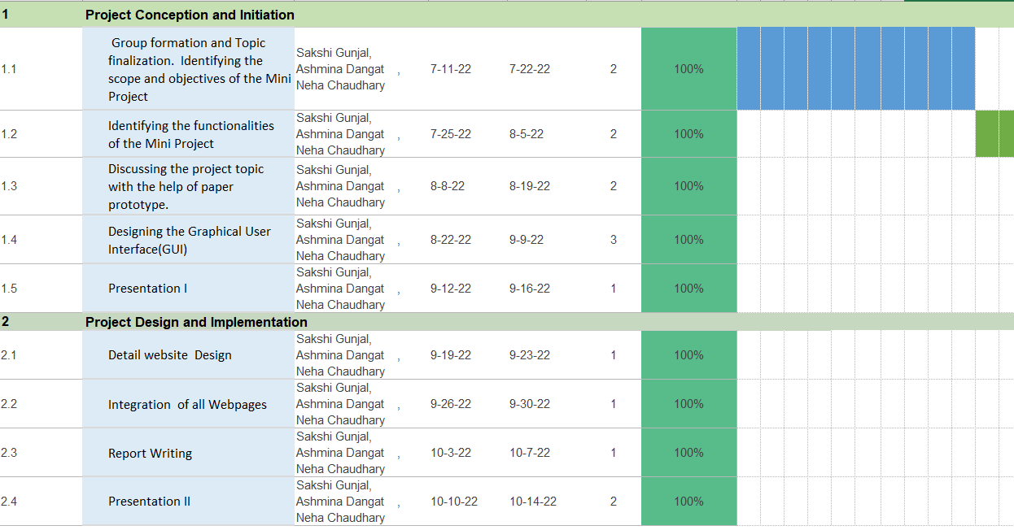

Fig 7.1 Gantt chart

**Chapter 8**

**Implementation**

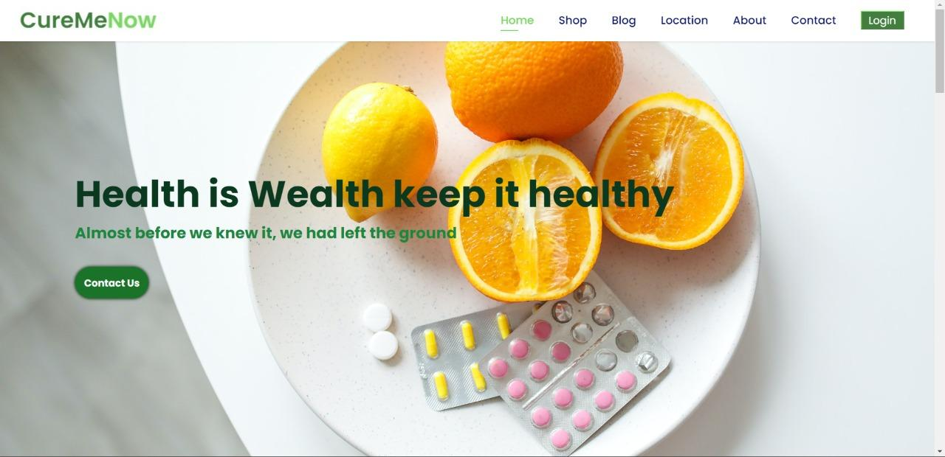

Fig. 5.3.1 Home Page (part 1)

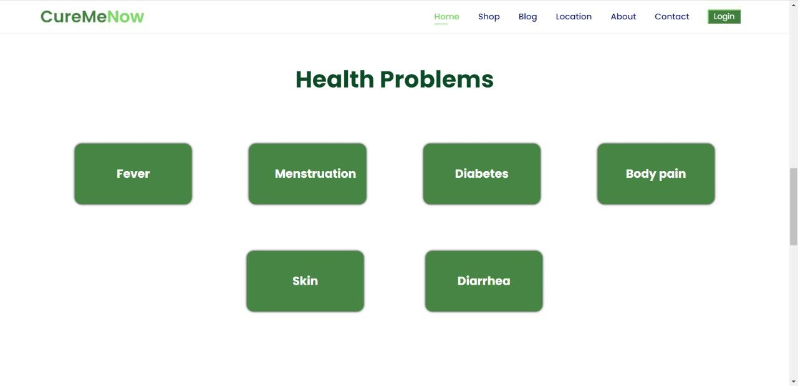

Fig. 5.3.2 Home Page (part 2)

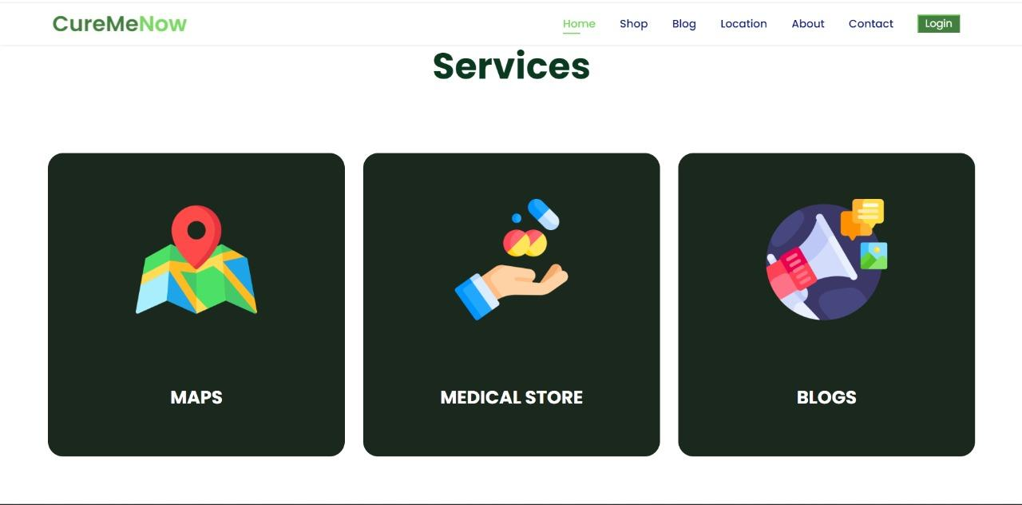

Fig. 5.3.3 Home Page (part 3)

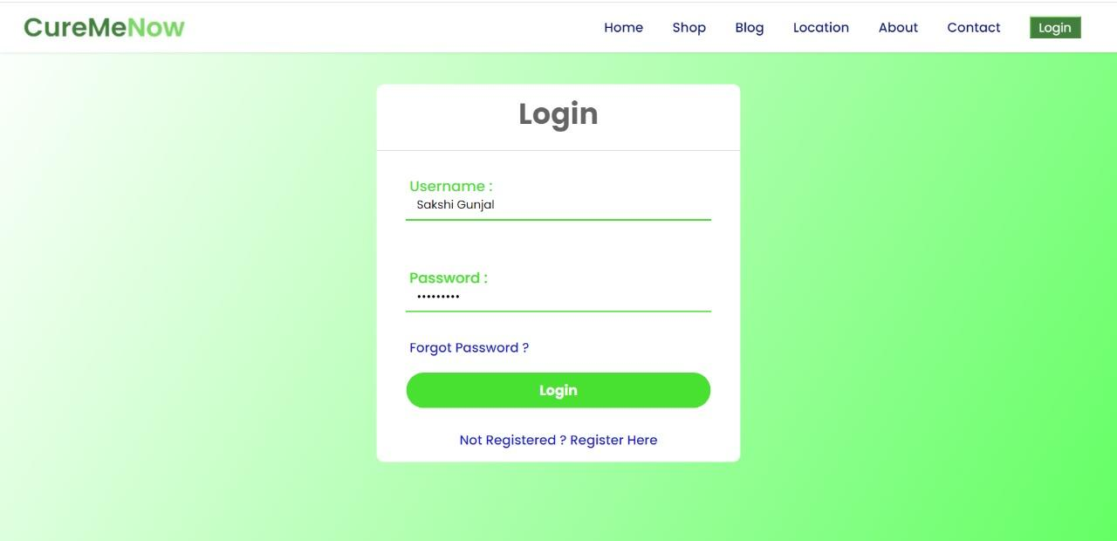

Fig. 5.4 Login Page

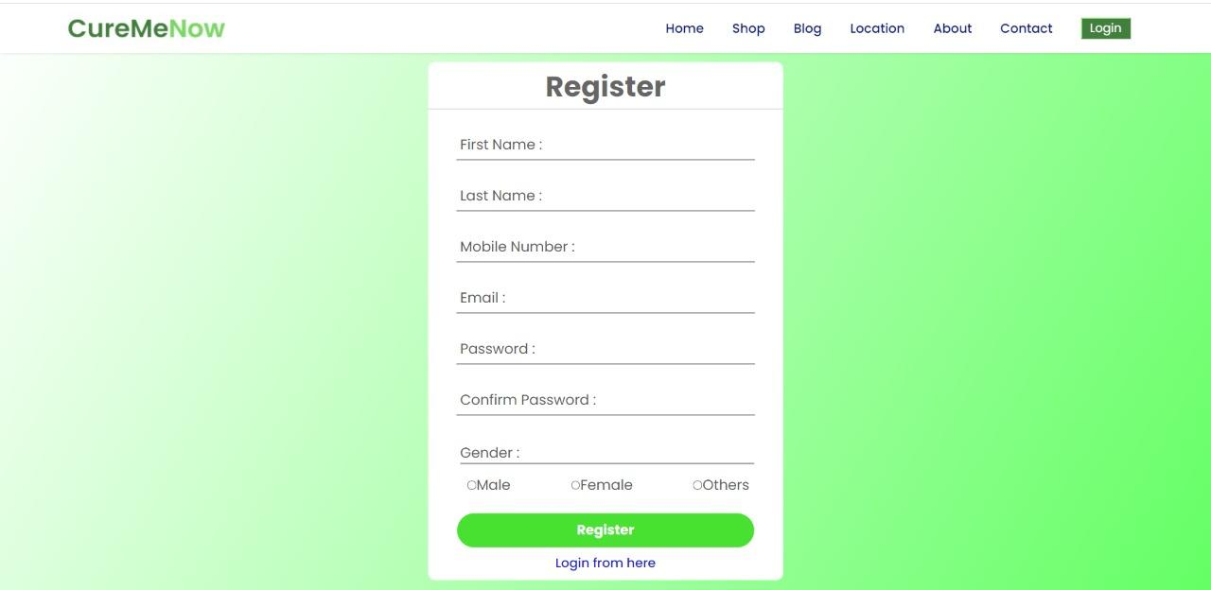

Fig. 5.5 Register Page

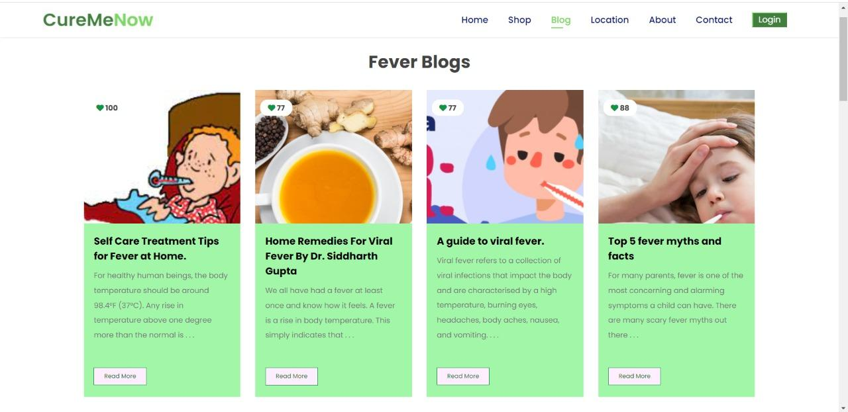

Fig. 5.6 Blogs Page

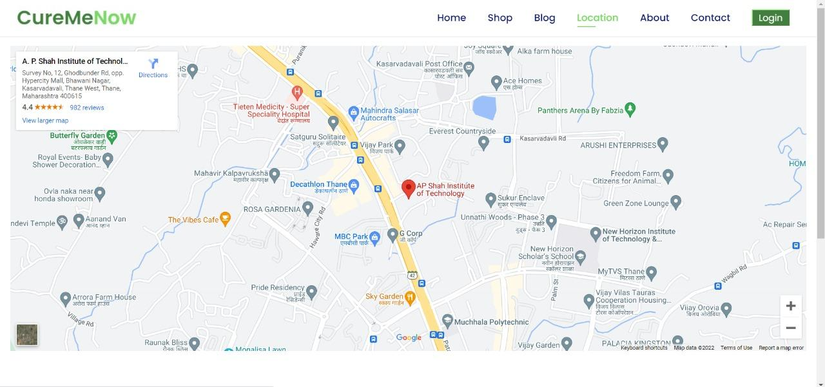

Fig. 5.7 Location Page

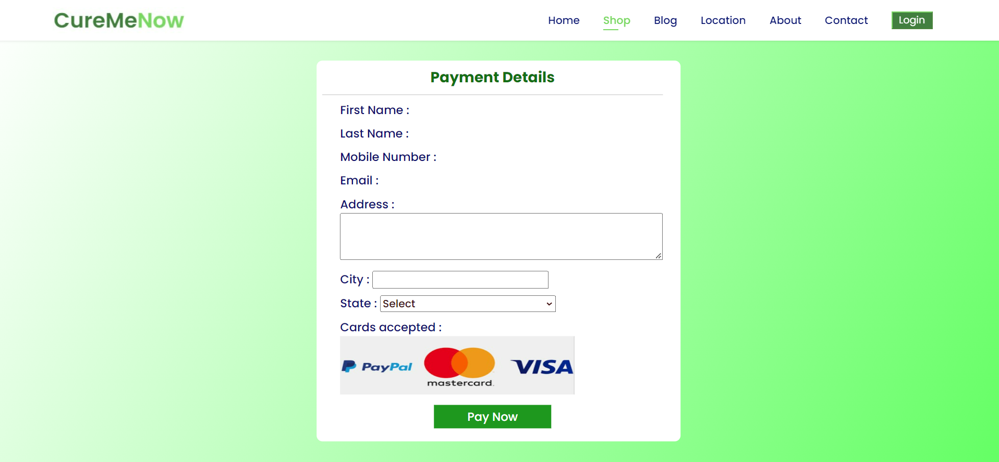

Fig. 5.8 Payment page

**Chapter 9**

**Conclusion and Future Scope**

**Conclusion**

Developing the medical system software is a great opportunity to create the distinct, and fast delivering healthcare module.Implementation of medical website project helps to provide user communication, manage financial and human resources, and market medical services. It helps to locate the medical stores and hospitals near your locality. It provides recommendations to the user’s problems and solutions to the problems. It avails users to shop various medicinal products. Concluding, the website is user-friendly and easy go for all the users.

**Future Scope**

* Solutions to more health problems.
* To give doctor appointments.
* To track products which are out for delivery.

**References**

* <https://www.researchgate.net/publication/300118919_Health_related_smartphone_applications_a_literature_review>
* <https://youtu.be/18Jvyp60Vbg>
* <https://drive.google.com/drive/folders/1aL6-dLiiMCg4oX6-bEj4ztrS72_gVPn4>